Light Lab
Station 1-Reflection
What you see when you look in a mirror, is called a reflection. This station will explore some basics about reflections.
Part a.) Examine your reflection on both sides of a spoon. Draw what you see. Can you explain how the shape of the spoon is causing this?
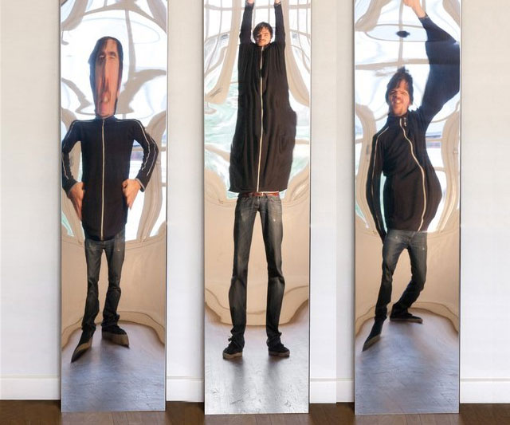
How does what you observed with the spoon explain what is happening with these fun house mirrors?

Part b.) Notice that there are two sheets of tinfoil. One is crumpled. One is smooth. Draw your reflection in both pieces of tinfoil. What do you notice? How can the shape of the two surfaces explain what you are seeing?

What you see in the crinkled tinfoil is called diffuse reflection. What you see with the smooth piece of tinfoil is called specular reflection. Use what you learned above to explain what is happening in Figure 1 below.
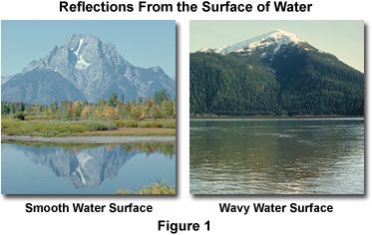
-USE YOUR OWN PAPER, PLEASE DO NOT WRITE ON!-
Station 2-Refraction
Light can bend. The bending of light is known as refraction. This station will explore refraction.
Part a.)
Pencil
Beaker
Protractor
In this beaker there are different fluids: molasses, water, alcohol, soap, oil, and air. Think back to 7th grade, do dense objects sink or float?
Will the more dense fluid be on top or on bottom?
What do you notice about the angle of the pencil in the different fluids?
Make a graph showing what you observe.

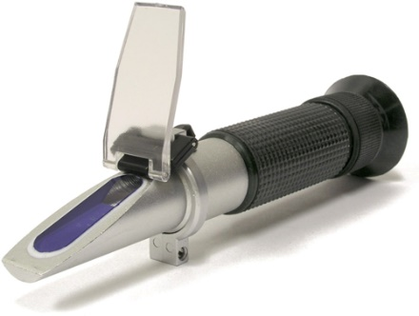
Part b.)
This instrument is called a refractometer. It uses refraction to identify different substances. Make a prediction about how you think it works.
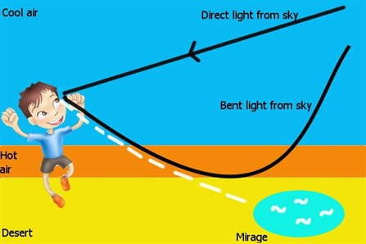

Part c.)
Temperature can also bend light. Below is a diagram showing how an eclipse works. Explain how this is related to refraction.

Part d.)
Gravity can also refract light. This is called gravitational lensing. Very massive objects bend space making it look like light travels in a different path than it actually does. How can astronomers use gravitational lensing to estimate the mass of galaxies and black holes?

-Please do not write on!-
Station 3-Rainbows
White light is actually made up of many different colors. These colors can be separated in a number of different ways. Light can be bent, called refraction, or light can pass through a small opening or slit called diffraction. Light can interfere with itself. This is called interference. This lab will focus on both refraction, diffraction, and interference.
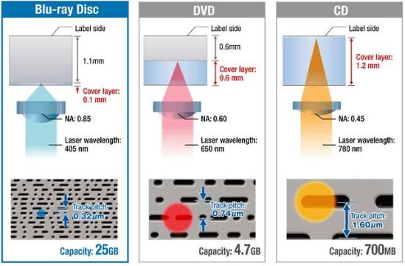
Part a.)
What color is sunlight? Place the DVD by the window. What colors do you see? What can you conclude about white light? A DVD works by having millions of microscopic pits on its surface. A laser scans these interpreting them as 1s and 0s which a computer plays as sounds and images. These microscopic pits. The different heights cause light to arrive at different times, strengthening some colors and minimizing others. Are the rainbows on a DVD caused by refraction, diffraction, or interference?
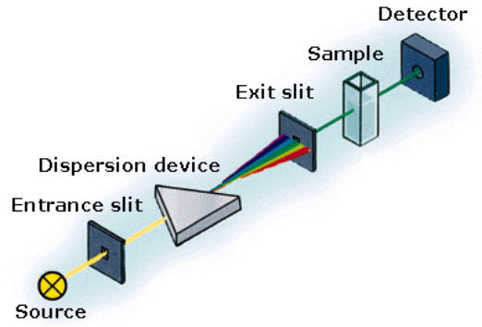
Part b.)
The device to the right is called a spectrometer. It uses diffraction to help astronomers determine the composition of stars. Light is passed through a thin slit. Is this refraction, diffraction, or interference?
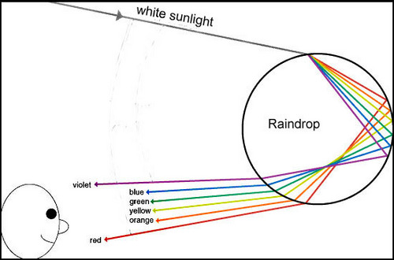
Part c.)

In both a raindrop and a prism, light is forced to bend and separate. This bending of light is what creates the rainbows we see after a rainstorm. Is this refraction, diffraction, or interference?

Part d.)
Soap films are different thicknesses. This causes different colors to interfere causing the rainbow film. Is this refraction, diffraction, or interference?

-Please do not write on!-
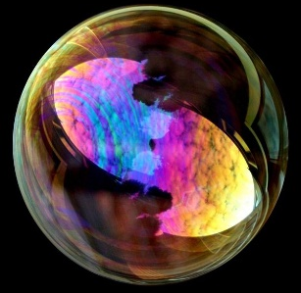
Station 4-Transparent, Translucent, & Opaque
Some materials allow nearly all light to pass through. They are called transparent. Some materials block a portion of the light, they are called translucent. Yet other materials block nearly all of the light passing through them, they are called opaque. This lab will help you distinguish between the three terms.
Part a.)
You have been given a clear sheet of plastic, a piece of colored paper, and some eclipse glasses. Your job is to determine which are transparent, translucent, & opaque.

Part b.)
If something is 100% opaque, how much light gets through? If something is 50% opaque how much light is transmitted? What if it is 0% opaque? How about 100% transparent, 0% transparent? If an object is 50% transparent, what is it called? If you made a graph plotting color and % opacity, what would it look like? What would it tell you?

Part c.)
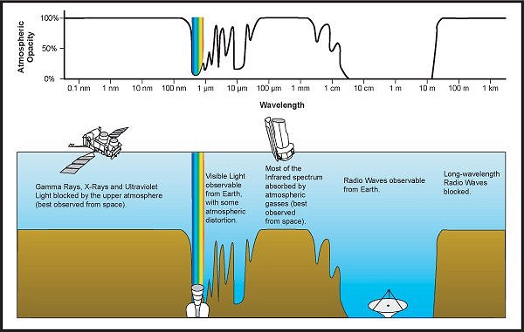
Many things can be transparent to one color and opaque to another. How would you explain this graph to someone who hasn’t taken science? What frequencies are Earth’s atmosphere opaque to, and what frequencies are it transparent to? Are there any frequencies that Earth’s atmosphere is translucent to? The Chandra telescope takes pictures of stars and galaxies using x-rays. Do you think this telescope is Earth based, or space based? Justify your reasoning. Why is it good for us on Earth that most ultra violet rays are blocked by ozone? What would happen if the amount of ozone decreased? Carbon dioxide blocks infrared radiation, what would happen if it increased?

