Scientist  Notes About Atoms | Important Dates | Model | Description
Democritus  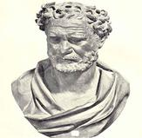 | 465 BCE | Atoms and the void. | He believed that at some point matter could no longer be cut. This particle was called the atmos, or the atom. Between atoms was empty space he called the void.
John Dalton  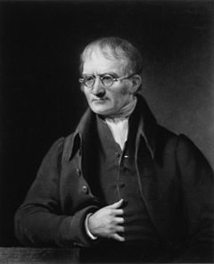 | 1803 CE | Atomic Theory | Everything is made of atoms. Atoms cannot be created or destroyed. All atoms of the same element are the same. Atoms will join together to make molecules in fixed ratios, example: two hydrogens plus one oxygen will always make water.
Dimitri Mendeleev  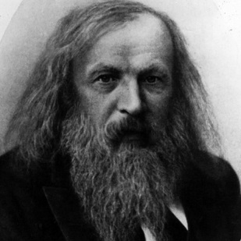 | 1896 CE | Periodic Table  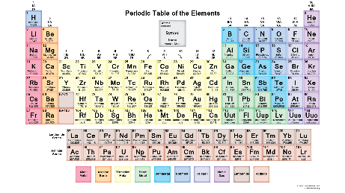 | Organized the periodic table as we know it—based on the number of protons aka the atomic number. This allowed him to make predictions about the properties of elements unknown at the time.
Joseph John (J.J.) Thomson  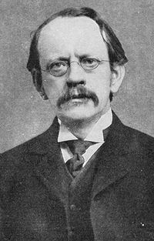 | 1897 CE | Plum Pudding Model  + - + _  - + | With the discovery of electron we realized matter can have a charge, but there must be equal positive and negative charge, otherwise everything we touch would shock us. Thomson proposed the positives and negatives were bundled together and blended uniformly like a soup or plum pudding.
Ernest Rutherford  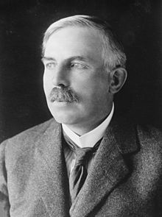 | 1912 CE | Planetary Model  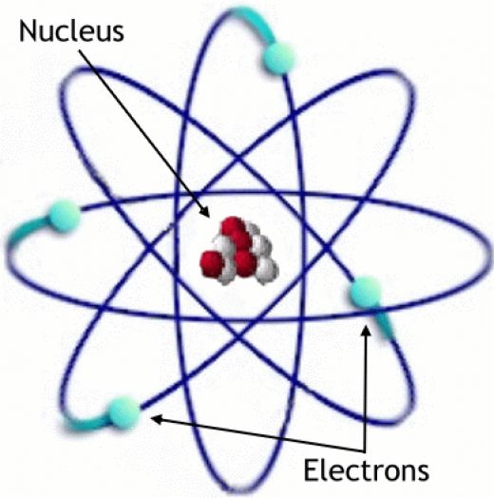 | Rutherford shot α particles at a thin gold foil, and by studying the way they bounced back, he realized that the atom is not uniform. Using terminology from a cell he called the central positive region the nucleus. Rutherford imagined the electrons orbiting the outer regions like planets, hence the name “planetary model”.
Niels Bohr  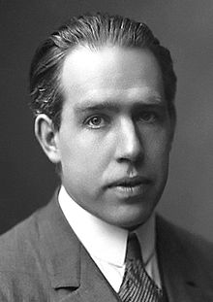 | 1913 CE | Energy Level Model  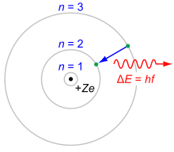 | Rather than being fixed in single orbits as Rutherford imagined, Niels Bohr conceived of the notion that electrons could jump between specified levels each with a different amount of energy.
Werner Heisenberg  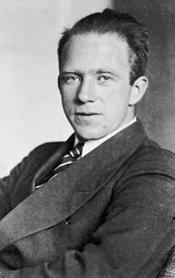 | 1926 CE | Electron Cloud Model  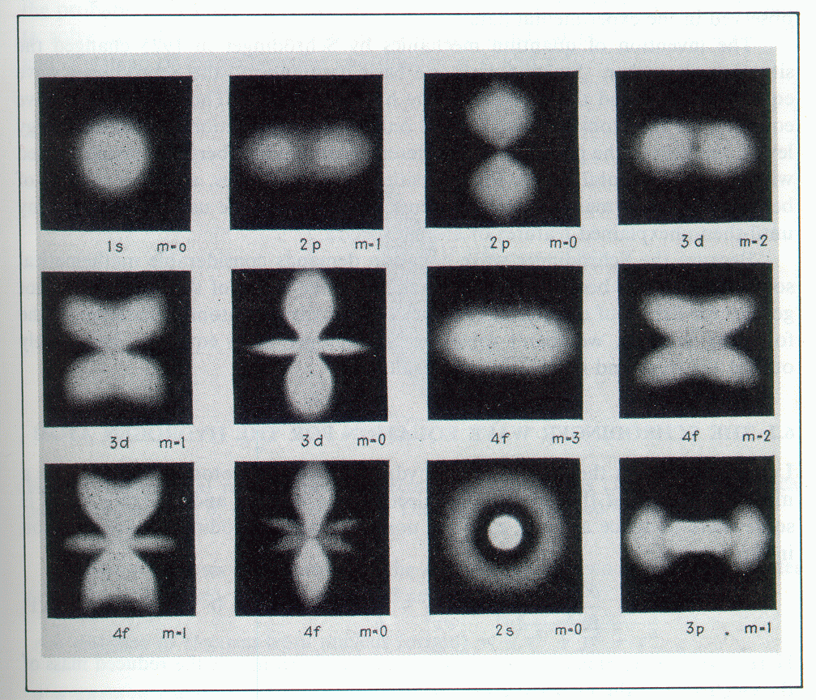 | Instead of the electrons being confined, Heisenberg proposed that they were more like a cloud and different atoms had different cloud shapes. The electron could be anywhere within the cloud and was best modeled by a probability function.
James Chadwick | 1932 CE | Neutrons  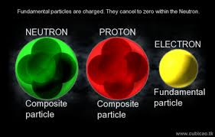 | Chadwick discovered the glue that holds together an atomic nucleus, the neutron. Its mass and charge is similar to a proton bound to a neutron plus a little bit extra to hold the combination together.

