Mr. Boom’s Term 1 Finale
This quiz is open book, open note, open internet. Use your head. Think. Don't copy and paste. Put things into your own words. You MUST show all work. All answers must be in complete sentences. All questions are related. You have all of the information you need to answer the questions, but you might need to look backward or forward to find it. Breathe. You can do this.
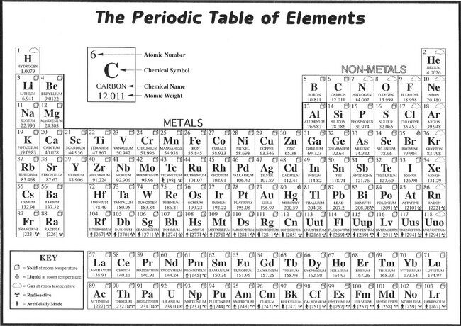

- You're bored during SRC. So you decide to go get some help with chemistry. Suddenly, you hear a little girl screaming in pain. You run over to the chem lab and see...

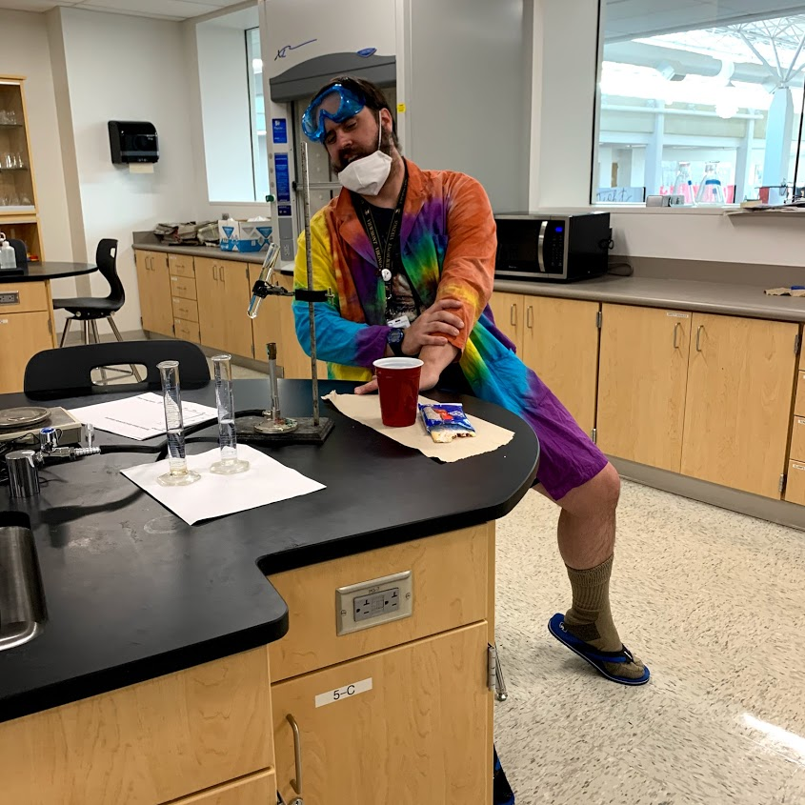
Mr. Boom got cocky and thought he could set up a demo without following proper safety rules. List as many things wrong with this picture as you can.

- You call an ambulance, but Mr. Boom passes out from the pain and is no help what so ever. In order to treat Mr. Boom the paramedics need to know, as exactly as possible, what he was playing with, and in what amount. After taking a careful look at Mr. Boom's station, you notice two graduated cylinders. You assume that whatever was in Mr. Boom's test tube is probably the average volume of the other two cylinders.
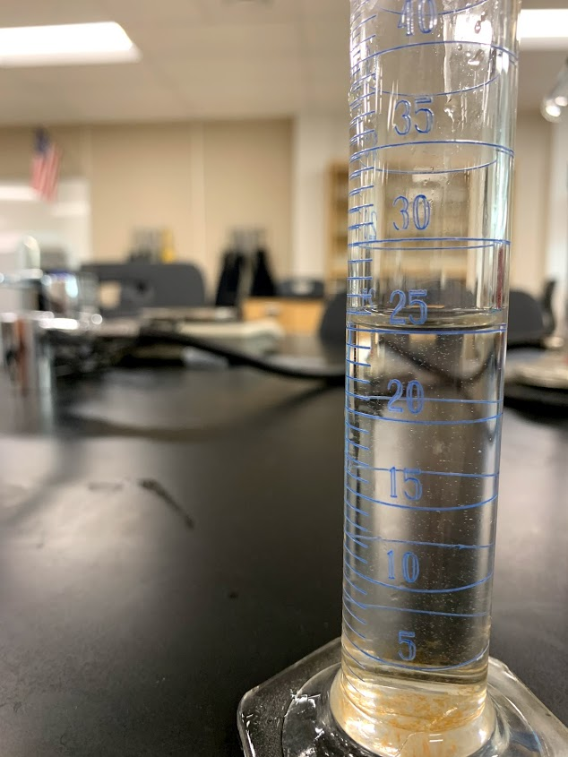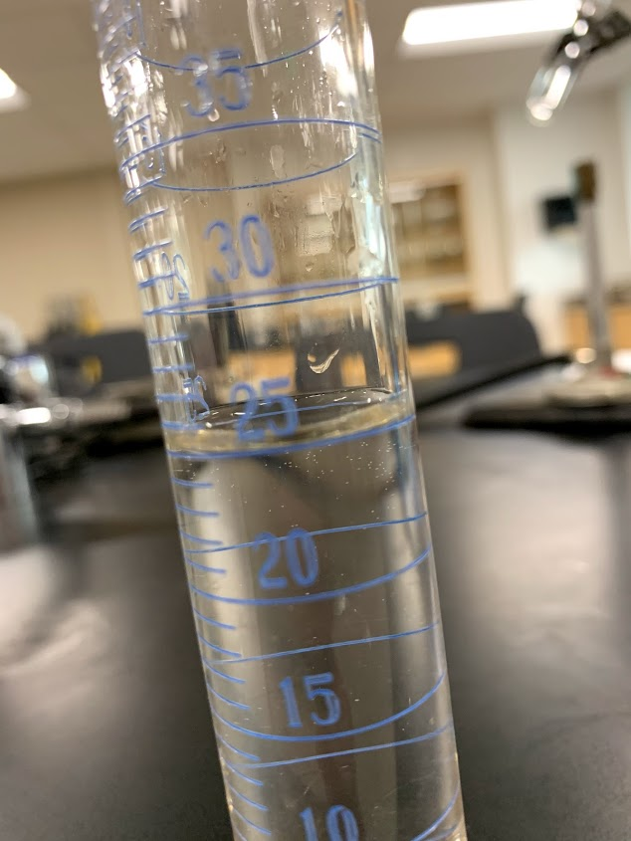

Approximately what is the volume to as many significant figures as you can, of the solution in Mr. Boom's test tube? Show and explain your work.

- The papers by Mr. Boom seem to be the read out of a mass spectrometer reading. You remember learning about mass spectrometers when your friend did the J.J. Thomson experiment. They operate on the same principle Thomson used to discover the electron. Based on what you know about Thomson's experiment, make a prediction for how a mass spectrometer might be able to determine the atomic mass of a compound.

- This question has parts A-F. Be sure to answer all portions.
Here is the mass spectrometer, or mass spec, read out.

A) How many elements and how many isotopes of each element are in Mr. Boom's sample? Explain your reasoning.

B) If the sample has 7 elements, multiply each percentage by 7. If the sample has 3 elements, multiply each percent by 3. Based on your observations, what should you multiply each of your percentages by?

C) What is the average atomic mass of each element in this sample? Show your work, and explain your reasoning.

D) Which elements does this sample contain? Explain your reasoning.

E) What is the total atomic mass of Mr. Boom's compound? Explain how you found this number.

F) Do the EMTs need to be worried about the sample being radioactive? Explain your reasoning.
5. A Material Safety Data Sheet (MSDS) contains information for first aid, clean up, and disposal of different compounds. Attached is a section from the MSDS for this compound. How would you advise the paramedics to treat Mr. Boom's injuries, and how should you clean up the left over material?

- What is the atomic mass of calcium (Ca)? What is the atomic mass of a lone oxygen (O not O₂)? What is the mass of calcium oxide (CaO)? What units are atomic masses measured in?

- Balance the following reaction, and explain your process.

___CaO +___ HCl =___ CaCl₂ +___ H₂O

- If an empty test tube weighs 24.47 g and the test tubes with Mr. Boom's solution weigh 54.47g, use the volume you determined earlier to estimate the density of the solution. How many sig figs should you report in your answer?

9. To calculate how much of the compound CaO you will need to clean up Mr. Boom's mess, follow this procedure:
1. Set up railroad tracks and cancel units appropriately.
2. Start with the volume/test tube in mL from Question 2.
3. Use the density of the solution you determined in Question 8 above to convert the volume into grams.
4. Use the atomic mass of the compound, found in Question 4E to convert grams of the substance into moles.
5. Use the coefficients of the reaction in Question 7 to convert from Mr. Boom's substance into moles of CaO.
6. Use the atomic mass of CaO from Question 6 to determine the number of grams of CaO you will have to add to each test tube, to neutralize its components.

Hints: Keep track of the units and what cancels. Show your work. If you don't know a number, look it up, or guess. Don't forget to use appropriate parenthesis in your calculations.

- Because of your heroic efforts, Mr. Boom recovers. With his last gasp as he is sent away to recuperate, Mr Boom says, "Convince me you learned something in chemistry."

