Cholesterol Chase
Grade Level: K-6
Skills: Students will demonstrate chasing, fleeing, dodging skills and basic health knowledge.
Objective: Standard 6.SDP.4: Analyze how various factors, including lifestyle choices, increase or decrease risk factors for disease. Students will enhance their knowledge of healthy eating habits in an engaging manner.
Equipment: 3-6 pinnies, 2-4 red hula hoops are needed for this activity.
Organization: Students will be in scatter formation throughout the gym.
Activity: Designate the taggers by having them wear the pinnies. Their task is to tag as many platelets (students) as possible. When platelets are tagged, they must go to an artery (hula hoop) until three are gathered. When they have three, then the cholesterol is too high and the only way to unclog the artery is to exercise. The three platelets must perform a quick exercise in order to reenter the bloodstream, e.g. 10 push-ups, 10 curl-ups or 10 jumping jacks. Change the taggers as often as needed.
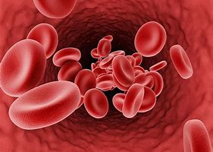

Health: What happens to your arteries when you have too much cholesterol?
What are some ways to reduce your cholesterol? e.g. healthy eating, exercise, lifestyle changes, etc.
How can lifestyle choices improve or harm your health?

Piloted at: Lakeside

